**TASK:**

UI/UX Design

**Overview:**

An “app store” is a popular way for a company to expand the capabilities of its product. Various SaaS companies are also building their own app/plugin/extension store specific to their product. A few of these are WordPress Plugins Store, Zoho Marketplace, VS Code Extensions Marketplace, Shopify App Store, and Figma Plugins Store. Your task is to redesign the app store for slack ([slack.com/apps](https://slack.com/apps)).

**Objective:**

Identify 2 problems with the current store and solve those in your redesign. Select 3 components that you used in your redesign and show all the possible states & variants for it. For example, the variants of a form field could be “errored”, “disabled”, “password”, etc.

**Deliverables:**

* Document where the research methods and inspirations are taken from.
* Hand-drawn or digital wireframes and flow. Any other UX analysis.
* UI of the redesigned screens (maximum of 5 screens).
* Documentation supporting how you solved the identified problems.
* 3 selected components and the possible states and variants for it.
* Figma or AdobeXD file or link.

SOLUTION:

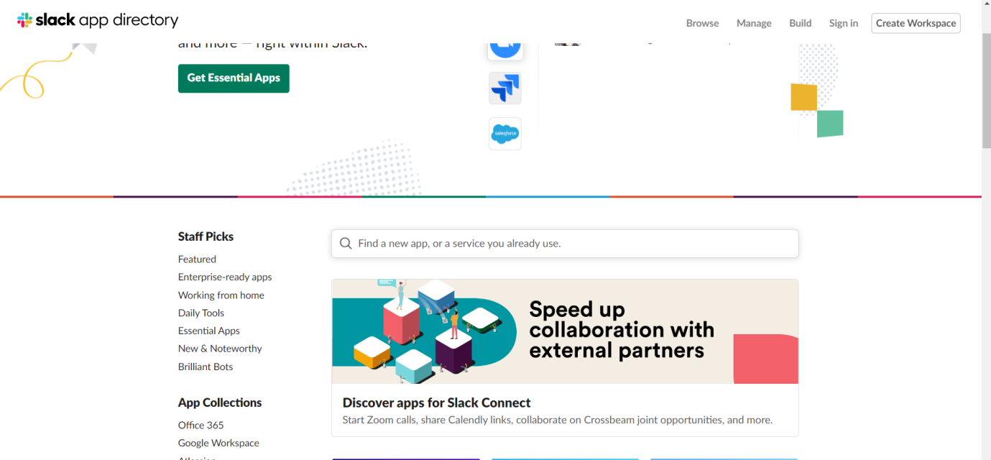

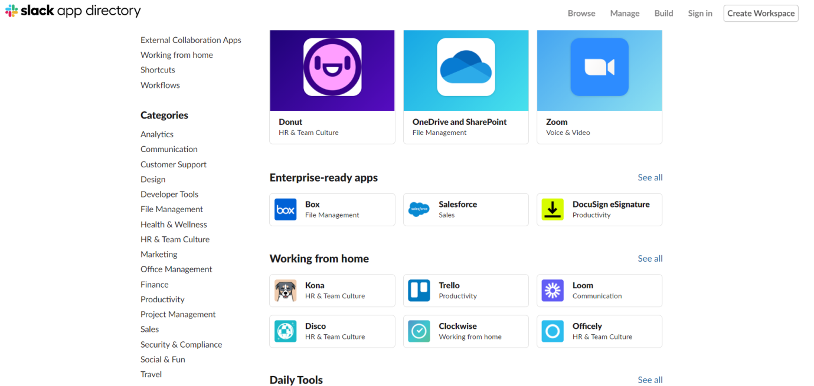

At a cursory glance, the above two screenshots represent the homepage of Slack PlayStore.

**Identifying the problem areas:**

As a first time user, the whole homepage didn’t appeal to me as it should have. As I explored the site, I was looking and comparing with other Playstores that I knew of, and how Slack fell short of them or had something different to offer.

First of all, like I said, the design of the homepage was not appealing. Secondly, most of the apps displayed on the site were new and relatively unknown from my experience. Hence, I felt that those apps, if there were important to be showcased in their respective genres, had to come with some quirky or fun design or even a short summary so as to appeal to the user to explore their benefits.

**Redesign Approach:**

For my redesign of the website I will concentrate on the number of apps and the type of apps to be displayed on the homepage. Starting with how I will go about displaying them. Simply putting them under different categories, as seen in Slack is not quite appealing. Hence I will keep a limited number of apps, with shifting background detail, highlighting their benefits/features accompanied by cool graphics to appeal to the user. This can be done for a few choice apps. The categories pane on the left side can be kept for a thorough perusal. But at the end of the page or preferably at the top, I will recommend to highlight and display new, trending apps or perhaps editor picks.

**Links for Research:**

<https://uxdesign.cc/how-to-redesign-step-by-step-guide-869379604734>

<https://blog.prototypr.io/product-design-exercises-we-use-at-wework-interviews-2ee1f5a57319>